Lab No | : | 02
Name of the Lab | : | Basic Linux Command
ID | : | IT-17005

Objective: The command line is one of the most powerful features of Linux operating system.
1. What is Linux operating system?
2. The operation of basic Linux command.

Linux Command: Linux is a Unix-Like operating system. All the Linux/Unix commands are run in the terminal provided by the Linux system. This terminal is just like command prompt of Windows OS. Linux/Unix commands are case-sensitive. The terminal can be used to accomplish all Administrative tasks. This includes package installation, file manipulation, and user management. Linux terminal is user-interactive. The terminal outputs the results of commands which are specified by the user itself. Execution of typed command is done only after you press the Enter key.

Basic Linux Command
01. ls: ‘ls’ command is used to show list the files and folders in the current directory.
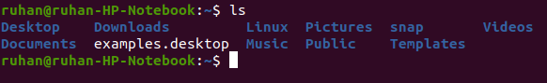
02. whoami: The ‘whoami’ command is used to find out who are logged in.
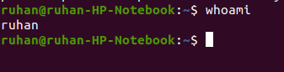

03. cd: The ‘cd’ command changes the current directory and moves
to the names of other directory.
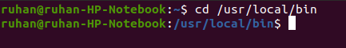

04. chmod: The ‘chmod’ command uses to set the file permissions flags on a file or folder. If the r, w or x character is present that file permission is granted.
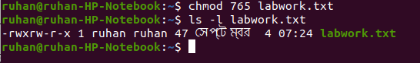
05. mkdir: The ‘mkdir’ command is used to create new directories in the file system. You must provide the name of the new directory to mkdir.
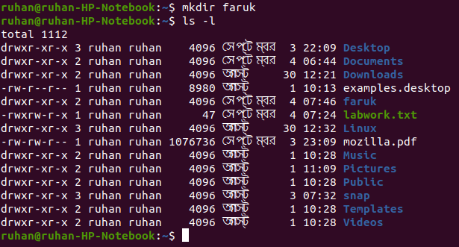
06. ps: The ‘ps’ command lists running processes. Using ‘ps’ without any options causes it to list the processes running in the current
shell.
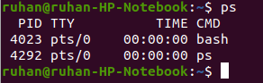

07. df: The ‘df’ command shows the sizes, used space and available space on the mounted file system of computer.
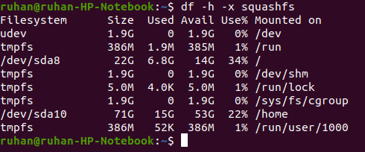

08. passwd: The ‘passwd’ command is used to change the password for a user.
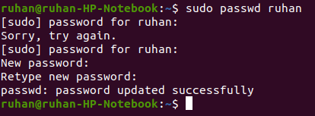

09. echo: The ‘echo’ command prints a string of text to the terminal window.
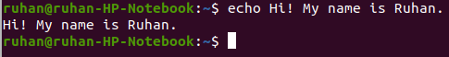

10. du: The ‘du’ command, short for disk usage, is used to estimate file space usage.
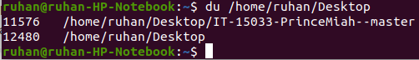

11. pwd: ‘pwd’ command prints the current directory (working directory) from the root/directory.
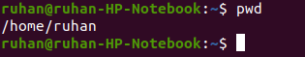

12. gedit: The ‘gedit’ command line allows the user to take advantage of several options unavailable from the GUI menu.

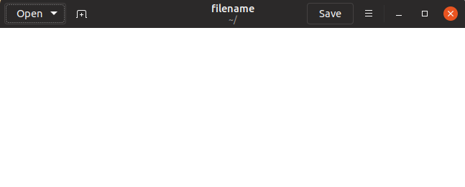

13. cat: The ‘cat’ command list the contents of files to the terminal window. To read the contents of your .bash_log_out file, type the
following command while the home directory is your current
working directory, as it is by default:
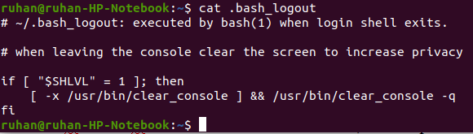

14. tar: The ‘tar’ command used to create an archive file(also called a tarball) that can contain many other files. You can also use tar to extract the files from an archive files.
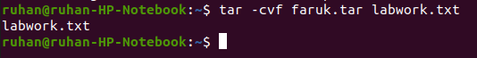

15. shutdown: The ‘shutdown’ command lets you shutdown or reboot your linux system. It bring the system down in a secure way.
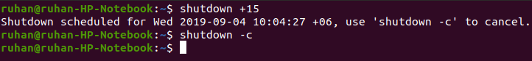
Conclusion: Linux is a open source and secure operating system.
Linux command line can be used like command prompt in windows.
Command line in Linux works as a different tools and perform specific tasks. From this lab we come to learn 15 command lines in Linux operating system.

